**Lynn’s Dutch Apple Pie**

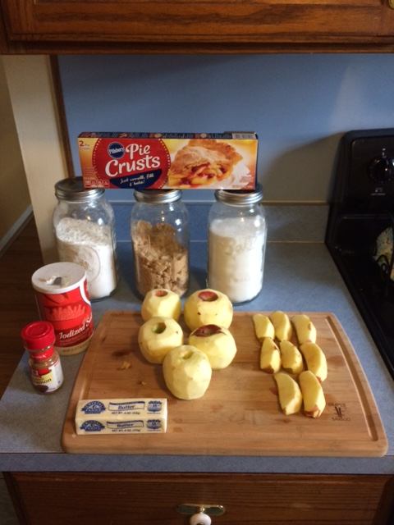

This is the recipe my mother in-law uses when she makes apple pies. Over the years I have tried to perfect the recipe and I usually will bring a pie when we are able to eat together as a family.

Below are the ingredients needed for the topping and filling:

**For the topping you will need:**

Two/thirds a cup of flour

One/third a cup of brown sugar

One/third a cup of butter

**For the filling you will need:**

Two pounds of apples (which is four to five large apples)

Two tablespoons of flour

Three/fourths a cup of sugar

Just a pinch of salt

One teaspoon of cinnamon

**Supplies needed:**

Two mixing bowls

Pie dish

Cooking tray

The piecrust is store bought which saves a lot of time in the preparation. She recommends the nine-inch Pillsbury piecrusts that you just have to unroll and shape to the pie dish. When you choose the apples for the pie you want to pick out a couple different types of red apples. I have found this helps to give the pie a real variety of taste. She also doubles the ingredients for the topping so it has a nice thick coating on top.

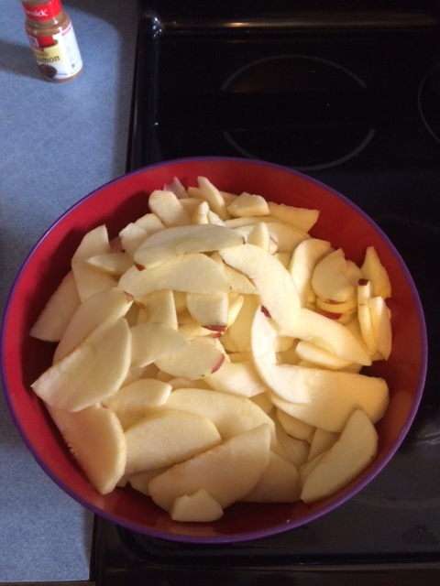

The longest part of making this pie is the time it takes you to peel the apples and then slice them thinly. Once you have completed this you can move onto the fun and easy part.

Step one: You will need a large mixing bowl to put the ingredients together for the topping. Measure out the two/thirds of a cup of flour and pour it into the bowl.

Step two: Measure out the one/third of a cup of brown sugar and pour it into the bowl.

Step three: Measure out the one/third cup of butter and stir it together with the other two ingredients until they are all brown and sticking together. Now set the topping mixture to the side until you completed making the filling.

Step five: Get the other bowl and pour all the thinly sliced apples you cut up into it.

Step six: Pour two tablespoons of flour over the apples.

Step seven: Pour three/fourths of a cup of sugar over the apples

Step eight: Put in a pinch of salt

Step nine: Put in one teaspoon of cinnamon

Step ten: Stir all the ingredients together until there is a nice glaze over all the apples.

Step eleven: take the piecrust and mold it to fit the entire pie plate

Step twelve: Pour all the apples from the bowl into the covered pie plate. Make sure to spread them out evenly so the pie doesn’t have any gaps in filling.

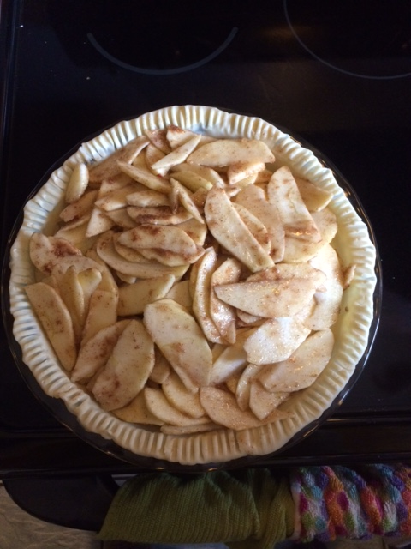

Step thirteen: Go get the bowl of topping and slowly pour the mixture over the pie until the there is a nice thick coating of toppings that covers the whole top.

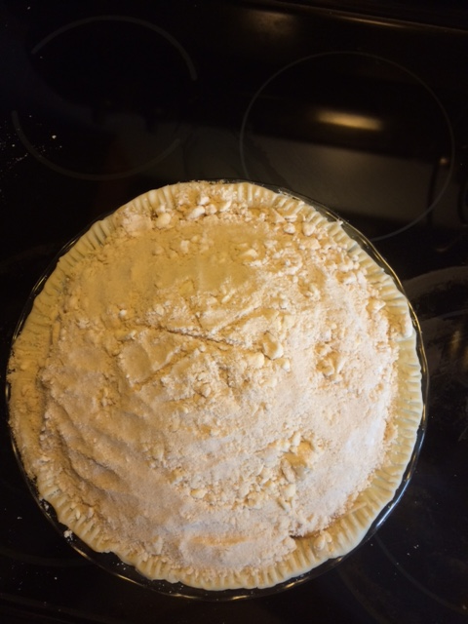

Step fourteen: You will need to bake the pie at four hundred degrees for forty to forty five minutes depending on how you like your crust and topping to come out.

Now Enjoy!

